Product Sense -

How to tackle product strategy and business acumen rounds in interviews?

Lecture Objective:

How to address business acumen questions round :

- Analyzing a metric change. What’s a metric?
- Defining metrics to measure performance / success of a new feature / product.

Importance of product strategy & business acumen rounds -

- Apart from building models, developing dashboards and reporting frameworks - One of the main responsibilities of a data scientist is to extract insights from data and work with product managers and engineering teams to deliver actionable plans to improve the product.
- Product sense is about understanding all possibilities, not finding one correct answer.

Example Questions: Product Acumen / Business Acumen
- Why did Youtube’s traffic drop by 5%?
- How would you measure the success of the “Save Post” feature on Facebook?
- What metrics would you define to measure the health of the product search in Amazon?
- We have a dashboard tracking our metrics and the avg ETA is up by 3 min. How would you investigate this problem?
______________________________________________________________________________

Flow of Discussion between CEO, Product Manager and Data Scientist.

CEO: Good morning, team. I'd like to discuss the upcoming launch of our new feature. Product Manager, could you provide an overview of what we're planning?

Product Manager: Certainly, CEO. We're introducing a new in-app messaging feature that allows users to chat with customer support directly. This should greatly enhance the user experience and improve our customer service.

Data Scientist: That's great news. To ensure its success, I suggest we monitor user engagement and response times closely. We should track metrics like chat usage, response rates, and customer satisfaction.

CEO: Agreed. Data Scientist, can you set up a framework to collect and analyze these metrics? Also, are there any early insights you can share about user behavior in our app that might be relevant to this feature?

Data Scientist: I'll get the data collection in place. As for user behavior, we've seen that users tend to spend a lot of time on our help center articles, which indicates a need for better support options. This new feature aligns well with that behavior.

Product Manager: It's reassuring to hear that. We're planning to roll out the feature to a small segment of users first to gather feedback. Data Scientist, do you have any recommendations for how we can structure A/B testing to measure its impact effectively?

Data Scientist: Certainly. We should set up the A/B test to compare user behavior and satisfaction between those with access to the new feature and those without. This will help us gauge its impact on engagement and customer satisfaction.

CEO: Sounds like a solid plan. Let's move forward with this strategy, and once we have collected enough data, we can reconvene to evaluate the feature's performance. Thank you, team.

Product Manager: Thank you, CEO. We're excited about this launch and the positive impact it can have on our users.

Data Scientist: Agreed. Let's work together to make sure we're making data-driven decisions every step of the way.

______________________________________________________________________________

Key responsibilities taken by the CEO, Product Manager, and Data Scientist in the above discussion:

CEO:
- Setting the overall direction and vision for the company.
- Initiating the discussion and requesting an overview of the new feature.
- Agreeing to monitor user engagement and response times.
- Leading the decision-making process and giving final approval.

Product Manager:
- Providing an overview of the new in-app messaging feature.
- Highlighting the potential benefits of the feature for the user experience and customer service.
- Suggesting the rollout of the feature to a small user segment for feedback.
- Seeking recommendations on structuring A/B testing to measure the feature's impact effectively.

Data Scientist:
- Suggesting the need to monitor user engagement and response times.
- Recommending the collection and analysis of specific metrics related to the feature, such as chat usage, response rates, and customer satisfaction.
- Offering insights into user behavior in the app, such as users spending time on help center articles.
- Proposing the setup of A/B testing to compare user behavior and satisfaction between users with and without access to the new feature.
- Agreeing to work on making data-driven decisions and collecting relevant data.

These responsibilities reflect the different roles and expertise of the CEO, Product Manager, and Data Scientist in the context of launching a new feature and ensuring its success.
______________________________________________________________________________

Judgment Criteria & General Framework -

Keep this in mind when addressing business acumen questions.

- Judgment Criteria for Interviewers :
  - Structure - Demonstrate a systematic approach
  - Comprehensiveness - Covers all important aspects
  - Feasibility - Practical enough that it could be implemented realistically
- General Framework to keep in mind :
  - Clarify
  - Plan
  - Conclude

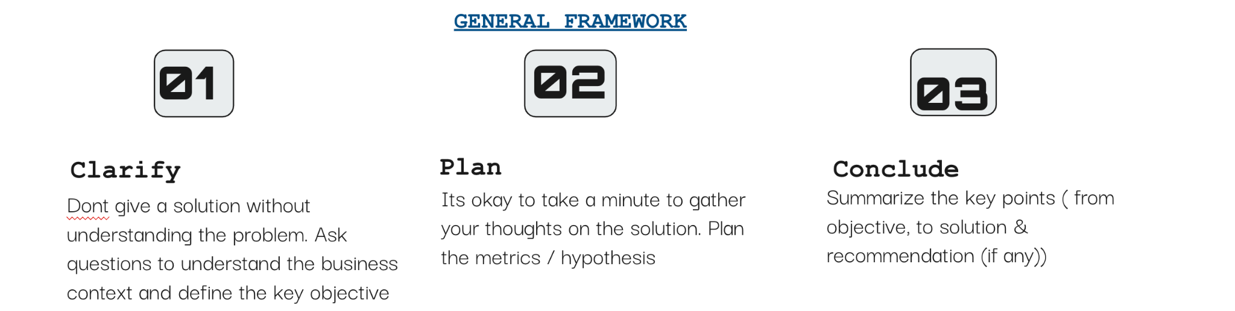

Different Product Sense Problems -
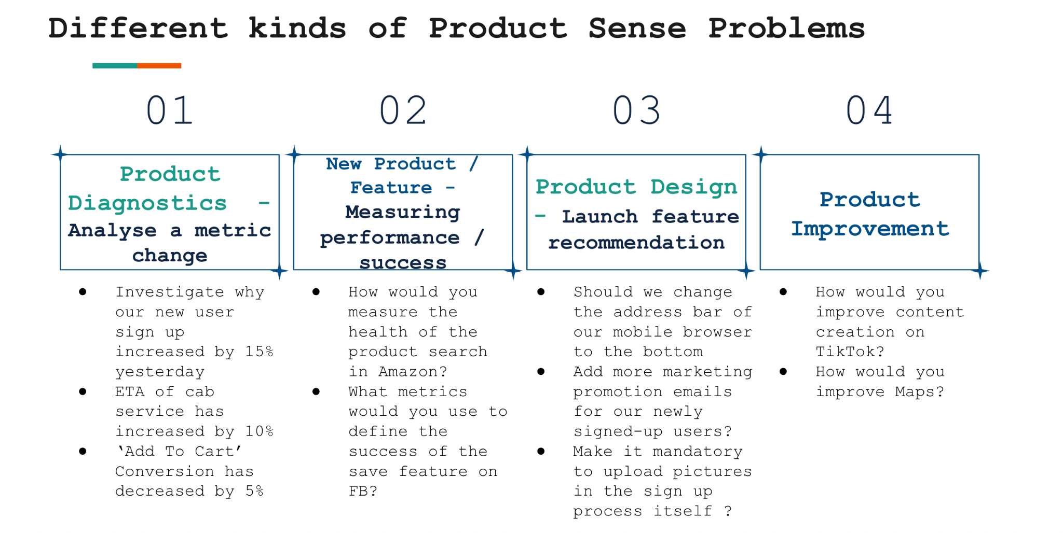

Product Diagnostics - Analyzing a metric change.

Case - You notice that the percentage of users who clicked on a search result about a Facebook Event increased 15% week-over-week. How would you investigate this?

General Framework -
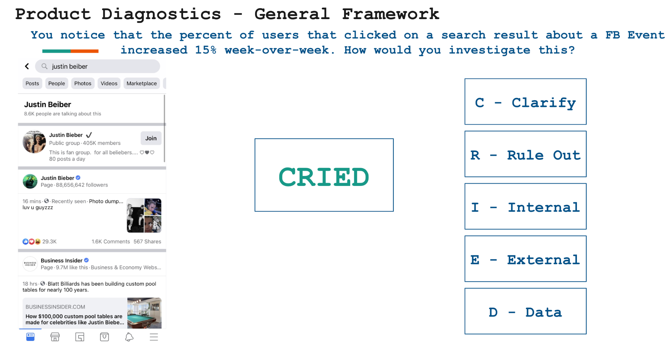
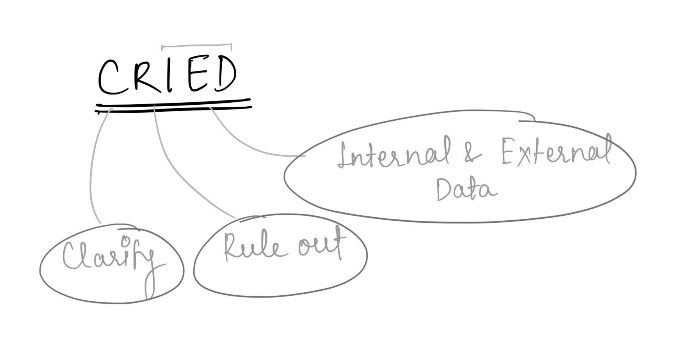

- Clarify: Ask clarifying questions and share what your thoughts about it are.

Below is an example of how you could drive this with the interviewer.

  - What does a search result success for an event mean?
    - Does it refer to when a user searches for something in the search bar on Facebook and the results produce a Facebook event?
    - These search results could belong to different categories, like a Facebook Event, Page, or Group - and the success is defined when you click on the event
  - You could also clarify the definition of the metric in question.
    - 15% increase = # users who clicked on event result after searching / # of users who searched for any keyword.
    - 15% WoW = 15% increase in success rate compared to last week? Or there has been a 15% increase over the past few weeks.

- Rule Out: Rule out any change in metric happening due to technical issues or infrastructural glitch / bugs or outliers.

  - Has there been any bug in the logging code because of which event clicks have been de-duped?
  - Is it a 3rd-party software tracking the search result clicks? If so, is there any glitch in that software?
  - Any data pipeline failure?
  - Ask about outliers - Did the metrics for the week get affected by one day’s data alone or has it been a consistent increase?

- Internal Data: Explore the internal factors that could have affected the metric.
Acronym: TROPiCS

  - T - Time:
    - Is this 15% increase seasonal / sudden / gradual?
    - Sudden Increase - could mean there is a bug in the logging of a new feature or update that's recently launched (ranking change?). This is creating problems so you may need to roll back.
    - Gradual Increase - may indicate a change in user behavior. Maybe users are starting to prefer live virtual events over physical events due to covid restrictions
  - R - Region:
    - Is this change concentrated in a specific region or is it evenly distributed globally?
    - For example, we are slowly coming out of the pandemic and some cities have started to reopen. In which case, the rising interest in events may only be concentrated in those cities that are not re-opened
  - O - Other related features affected:
    - If an interest in events is going up, do we see a similar jump in Instagram or Facebook stories because users attending these events will have more content to post about?
  - P - Platform:
    - Are we seeing this increase across both Android / iOS?
    - Across Mobile / Desktop?
    - Across Mac / Windows?
    - If only one of them is seeing an increase, we should explore if there’s an engineering bug with the platform that has caused a glitch
  - C - Cannibalization: If the metric for a product is decreasing, is it because another product we offer is cannibalizing engagement?

Alternatively, if the metric in question is increasing, are we cannibalizing from our other offerings?

    - Around the time when the spike in event clicks happened, are we seeing a decrease in # clicks on profiles/pages / groups?
    - Is there a specific category that we’re cannibalizing from or is it evenly distributed?
    - For instance, is it only users that previously clicked on Groups (not Pages) that are clicking on Events now?
      - This may indicate that we made a change to the ranking of Groups in our search results.
      - Did we down rank it? Or accidentally remove it completely?
  - S - Segmentation: Slice and dice the data to identify the demographic of users this increase has affected.

    - Age - Are we noticing this increase only amongst teenagers / young adults / middle age or senior users?
    - Gender - Is this increase only among female users? Or across both genders
    - Power Vs Casual Users - Are we observing this increase only among those users that are less active on FB?
    - New Vs Existing Users - Are we observing this increase only among those users that recently joined FB? Are the existing users still exhibiting same behaviors
- External Data:
  - Industry/Competitor
    - Did the # of users attending events on Twitter decrease?
    - A new competitor has joined the market.
    - Are competitors changing their offering?
  - Good PR
  - It could also be due to seasonality or a major temporary event.
    - If it’s a major temporary event, you should see KPIs begin to return to their normal state shortly.

2. Measure Product Performance / Success - Defining metrics

Case - PM reaches out to you after launch of a new save feature on Facebook to assess the success of this feature. Define the metrics you would like to measure.

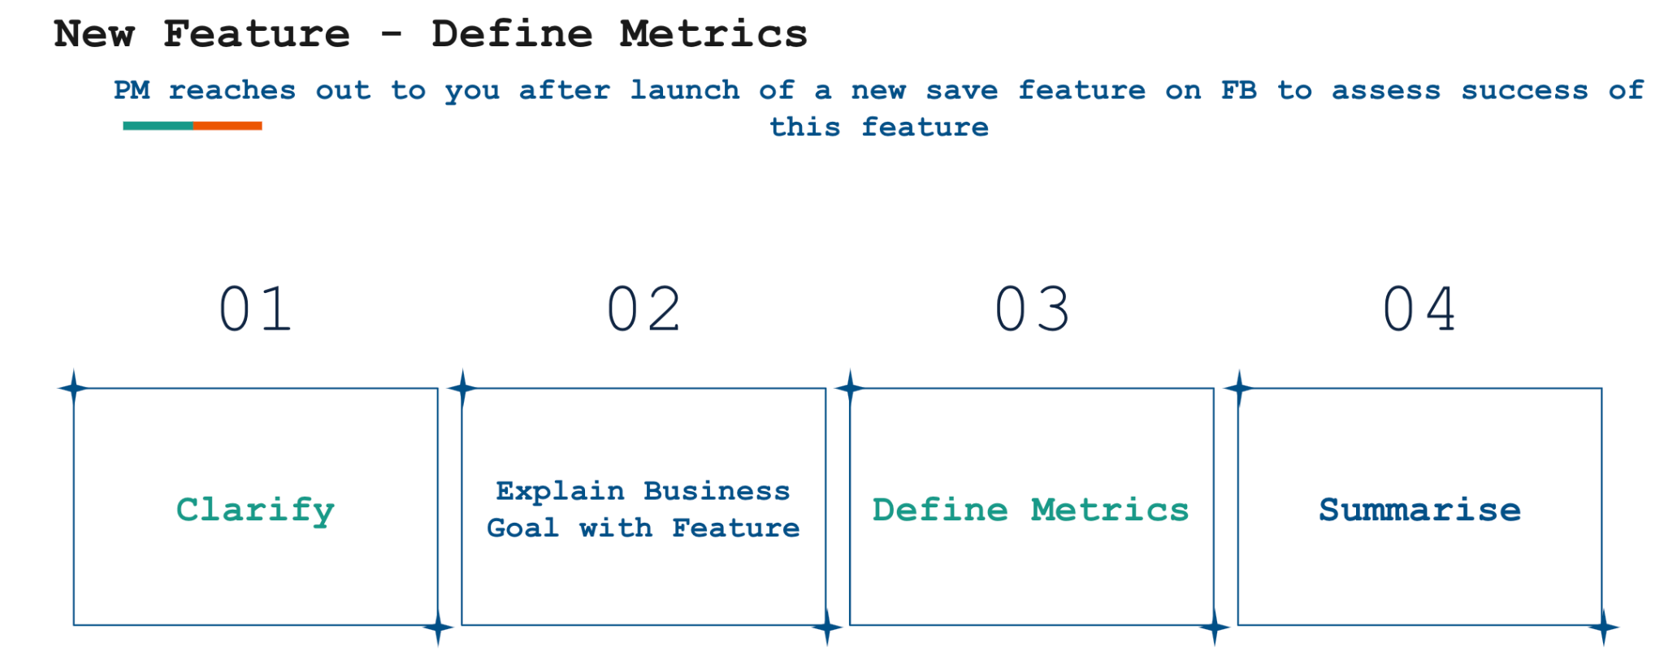

- Clarify: Ask clarifying questions about the new feature / product and the main objective behind its release (monetization, engagement, retention etc).

  - Is this save feature used to allow users to Save Links, Pages, Posts, Locations, Movies, etc. to view later?
  - Does this also remind users about what items they have saved later?
  - Are we focusing on both aspects of this feature or only the first?
- Who Benefits from This Feature: This feature affects users and marketer?

  - Marketers do not want to be forgotten, so if they post something that attracts the attention of the user, they want the user to be able to find it again later if they don't have immediate time to spend on it.
  - For example, if there is a nice shoe advertised on FB and the user likes it, but cannot check it now, or there is a discussion about a TV series that the user potentially finds interesting to watch later, the user can save it to check it out later.
- Business Goals:

  - User Goal: The benefit for users is that they do not need to copy paste or take a screenshot of the post they want to check out later. They can have all these items in a categorized way (e.g., Movies, Pages) and can check them later.
  - Marketer Goal: Increases revenue for marketers by increasing clicks and impressions.
  - BIZ Goal: Increases user engagement.
    - Increase revenue by increasing CTR, and CPC and CPM. Because the user might make a click that he would not have done otherwise if they could not save the post. So, the goal is to increase CTR and consequently the revenue.

- Define Metrics:
Please note that not all elements are applicable to all problem statements.

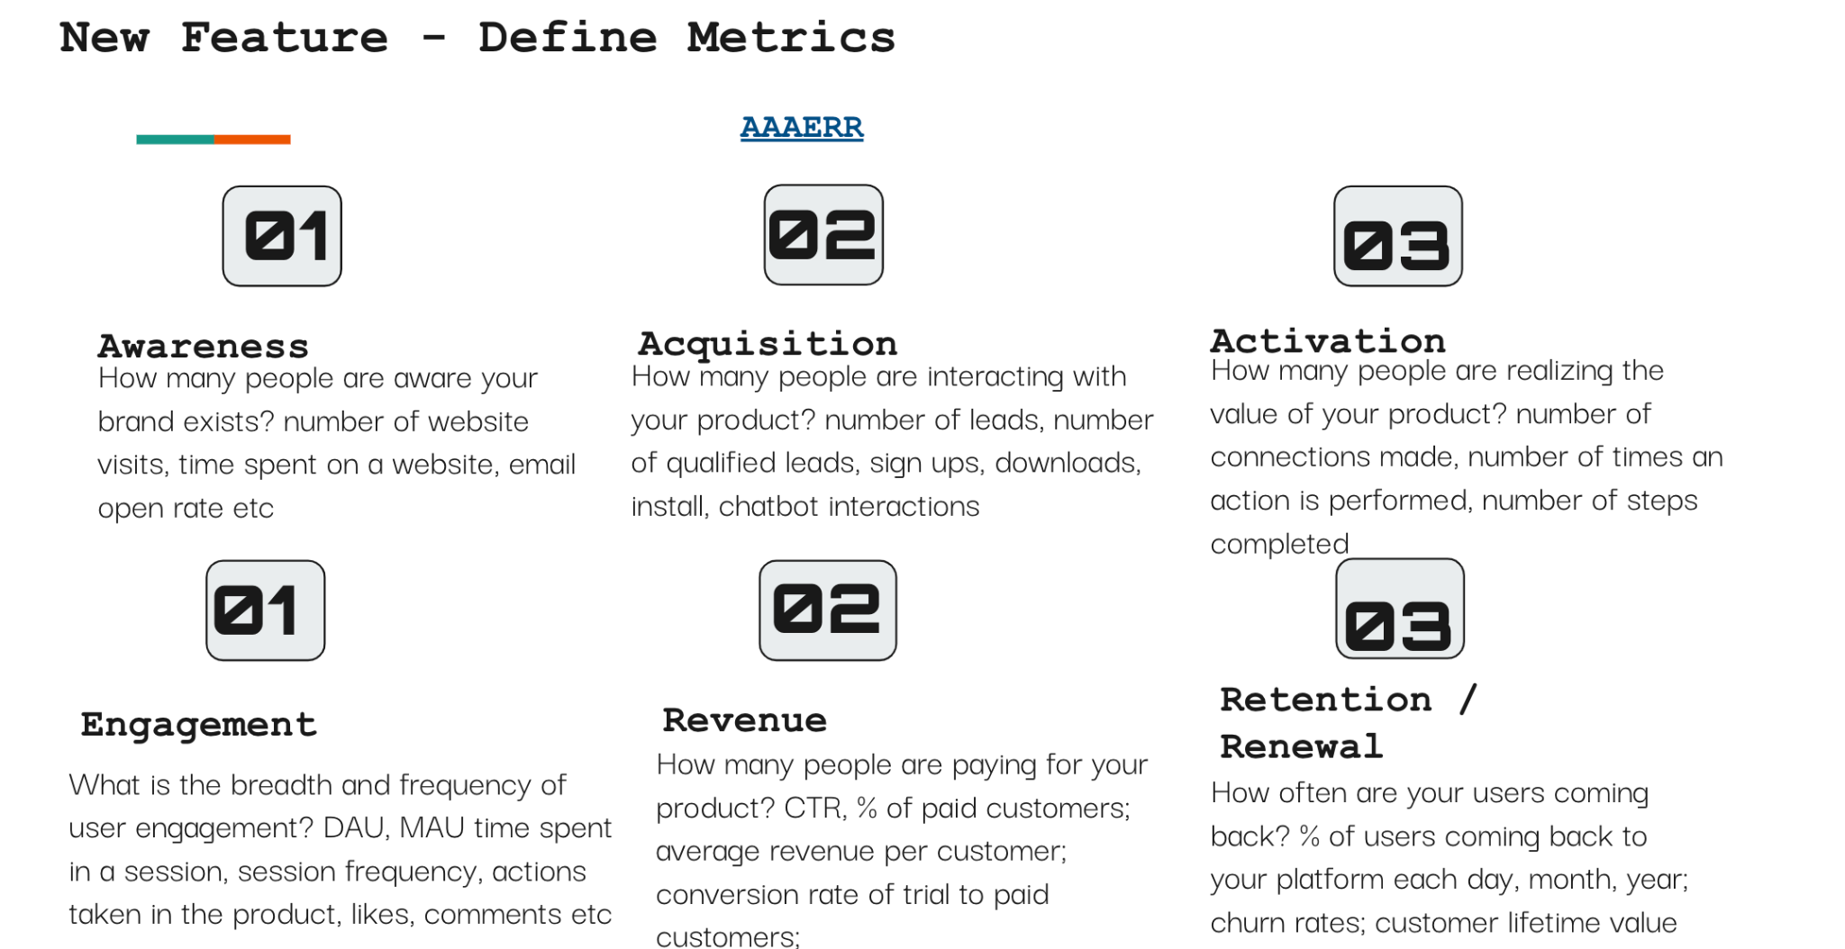

- Awareness:
  - Discoverability:
    - % of users the have at least once Saved an item
      - This shows that the users know about this feature.
    - # of returns to saved content per user
      - % of users returning to view saved content organically (on their own) - User knows where to find Saved items and knows how to work with it.
      - % of users returning inorganically (i.e., reminded by
      - Facebook to view saved content).
- Acquisition:
  - # of new clients who want to advertise with Facebook.
  - Increased spending of existing clients with Facebook since the launch of the save feature.
- Activation:
  - Adoption:
    - % of total posts saved (# Saved Posts / # Total Posts)-Indicates the adoption rate of the save feature - # people using the save feature actively.
- Engagement:
  - Average number of likes, comments, shares per saved post on a daily, weekly, and monthly basis- indicates the user engagement on a broader level. Compare this with a general post with no save feature and see if the engagement is more with the new feature.
  - %of Saved items that the user opens from the Saved page.
  - Amount of time spent on a page, after opening it from the Saved page.
  - The average amount of time it took a user from Saving an item to opening it again.
- Revenue:
  - % revenue increase just based on clicks and impressions made through the funnel that includes Saved items.
- Guardrail Metrics:
(Along with success defining metrics, it's also important to define guardrail metrics)
  - Has the success metrics of other features gone down because of the launch of the save feature?
    - For example, Although the save feature is leading to a lot of users saving the video, they fail to actually come back to the saved page and watch it. This reduces engagement in video content.
  - %of Saved items that the user deletes without engaging with or opening them.

